**[ Practical ] Object Oriented Programing: 3-10-2023**

Create new Java Project: Basic_programing

Create new Package Name: com.trainning.org

Create new Class Name in src folder: Complex.java

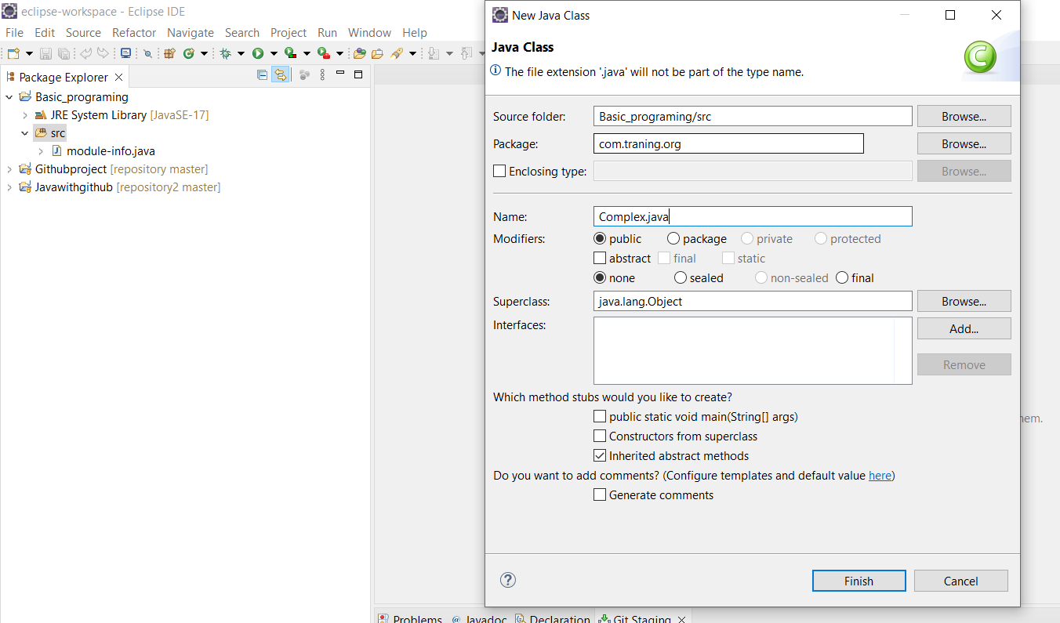

Write some constructor then also use debug to find error:

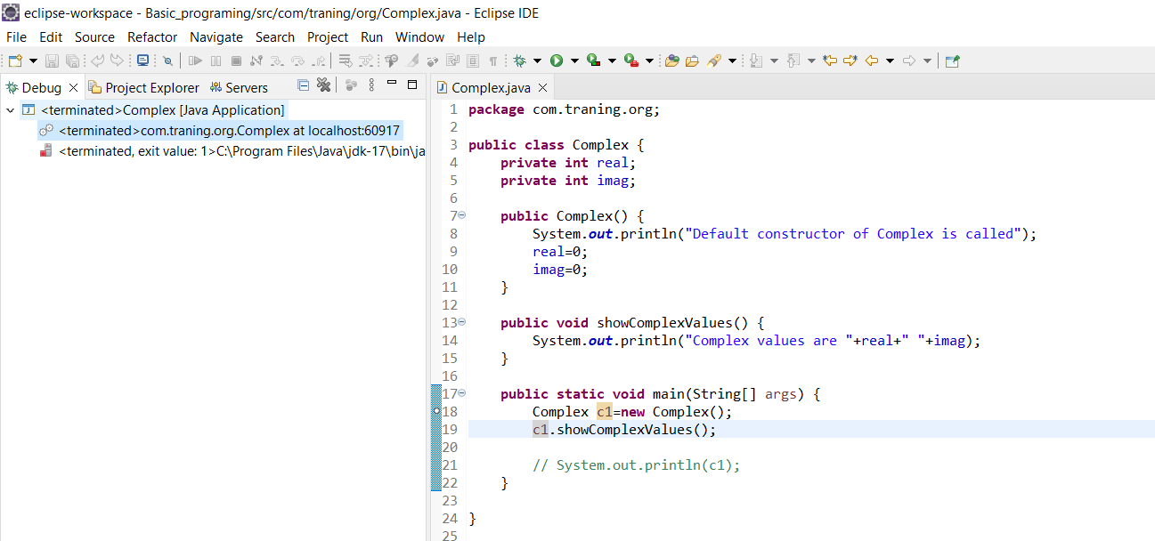

Create Breakpoint for debug:

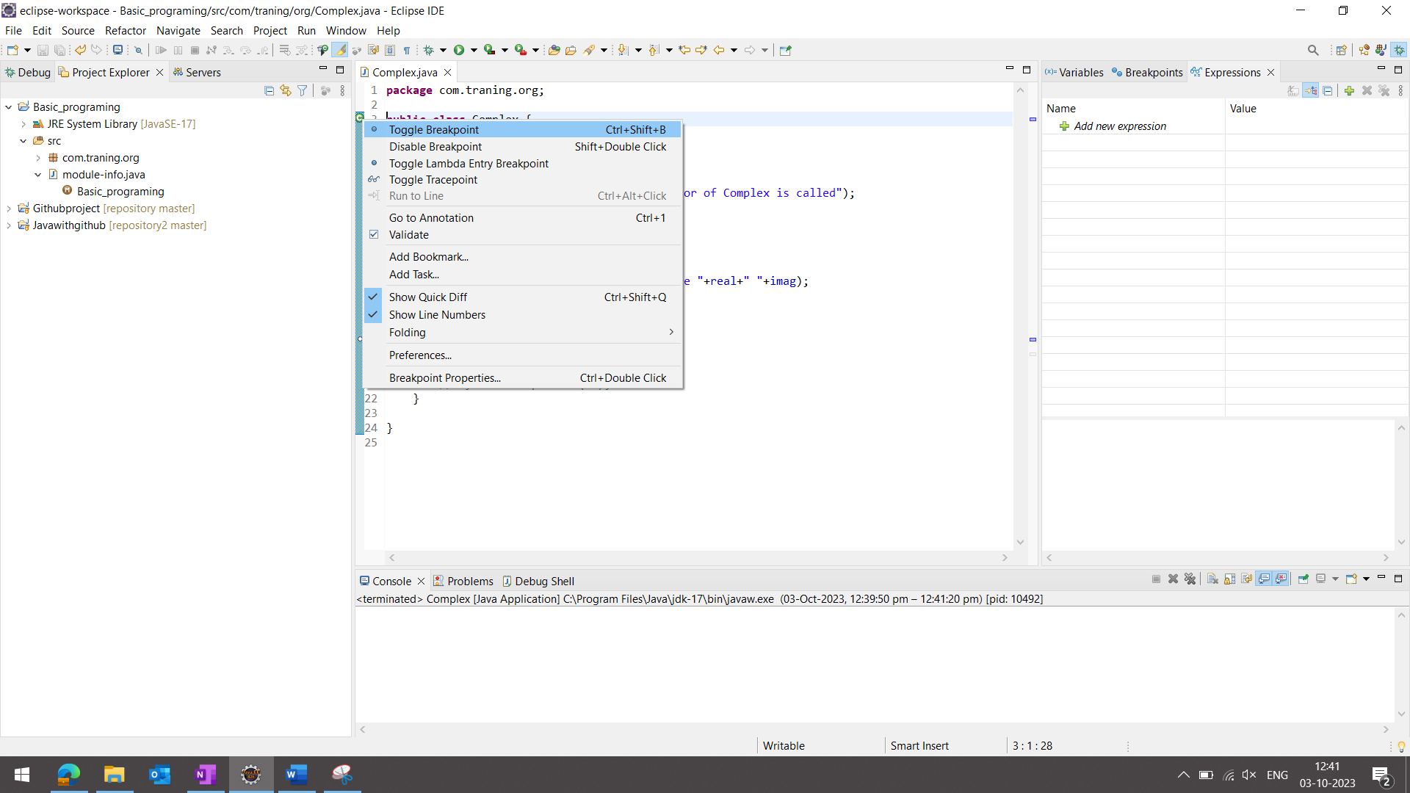

If you want to stop debugging then you can eassyly click read button.

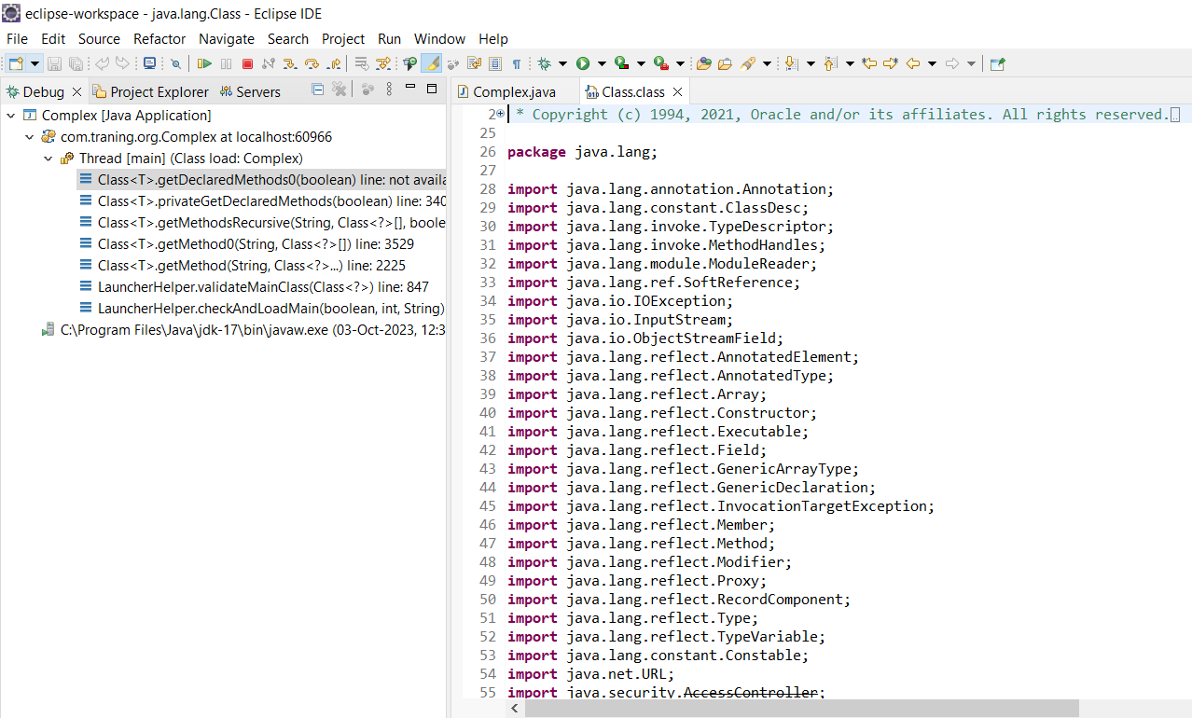

There also option **step into(F5)**:

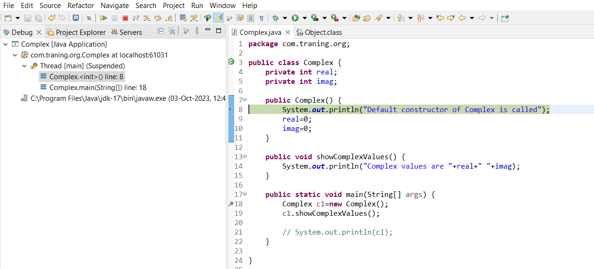

for loop with step over debug:

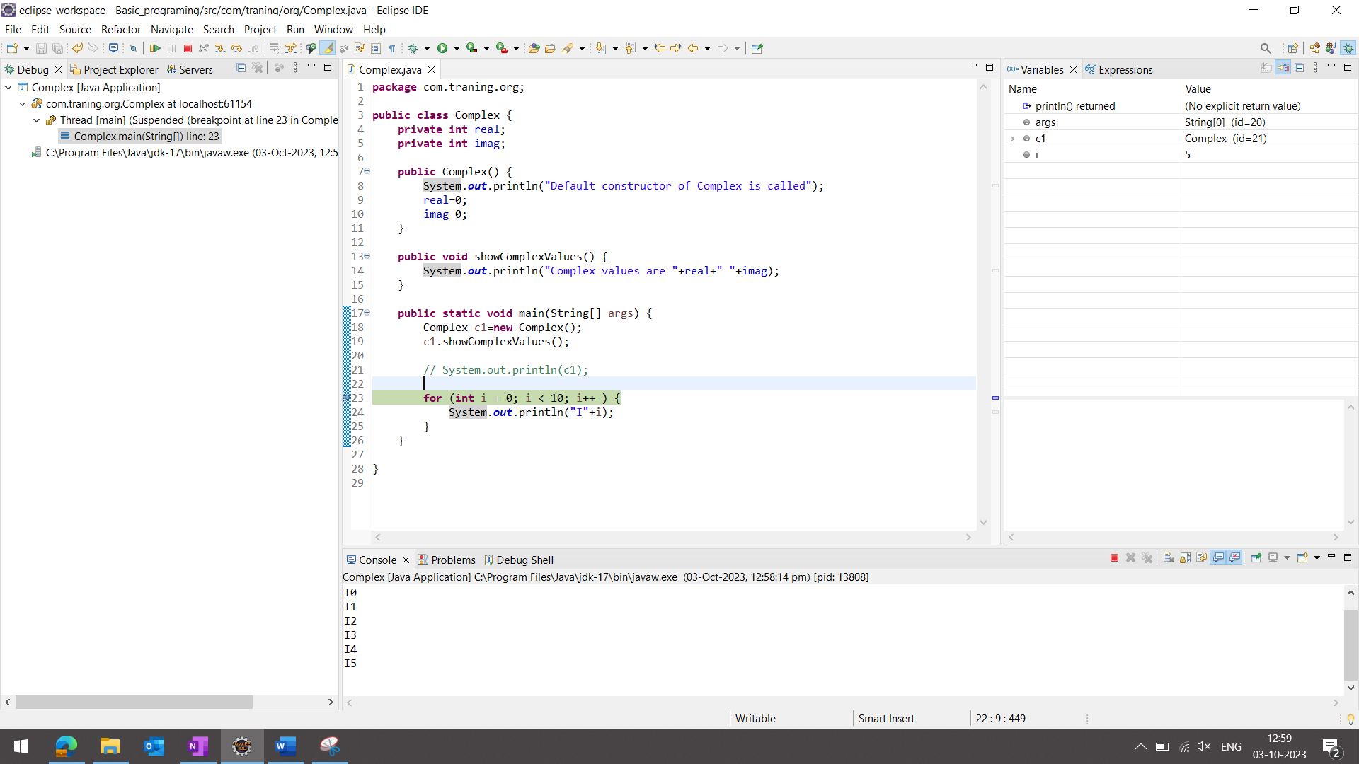

**Trigger Point with Hit count:**

